Credit Card API for use by Third Party

Here is a brief description of the Credit Card API and how it is to be used by Bank’s customers for paying for some third party’s products or services.

Let’s say some customer wants to use his/her credit card for paying their electricity bill. He/ She will go to that third party’s website and choose the option of credit card for payment. The customer should be redirected to our API running on our server at the address

http://<server_ip_address>:8000/creditcard/api/payment_api.html/account_no=897/amount=87/

where, <server_ip_address>:8000 is our server address for the API. The account number provided should be the one in which the mentioned amount payment is to be debited. The customer is then redirected to the following page:

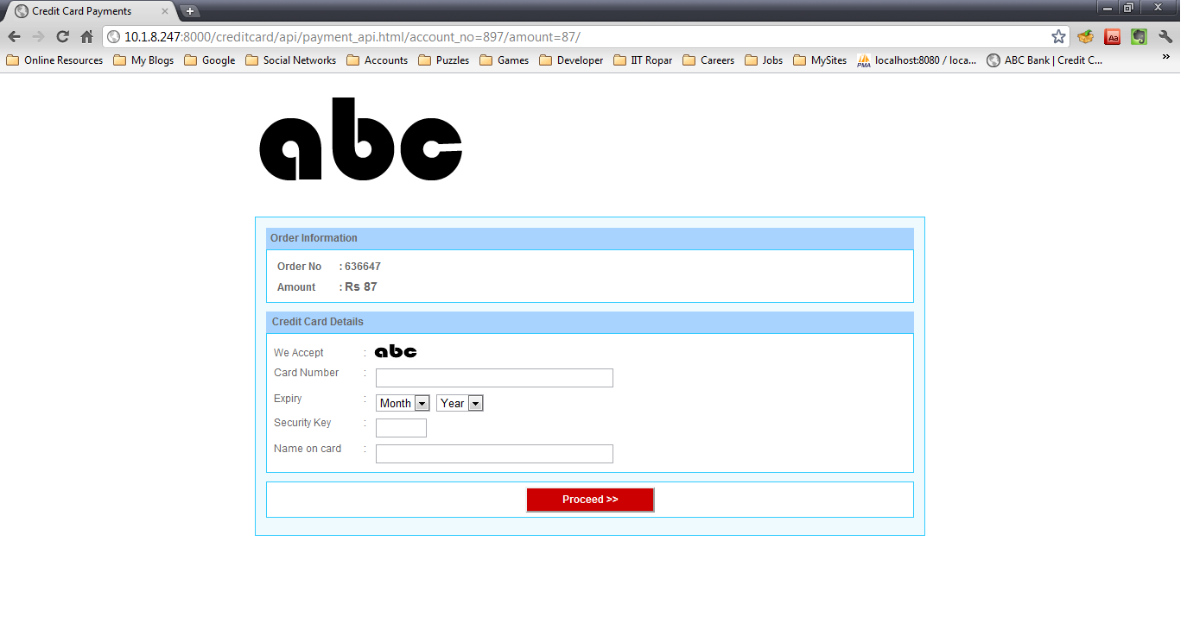

When the customer fills in the details, he/ she are redirected to the following page showing successful transfer:

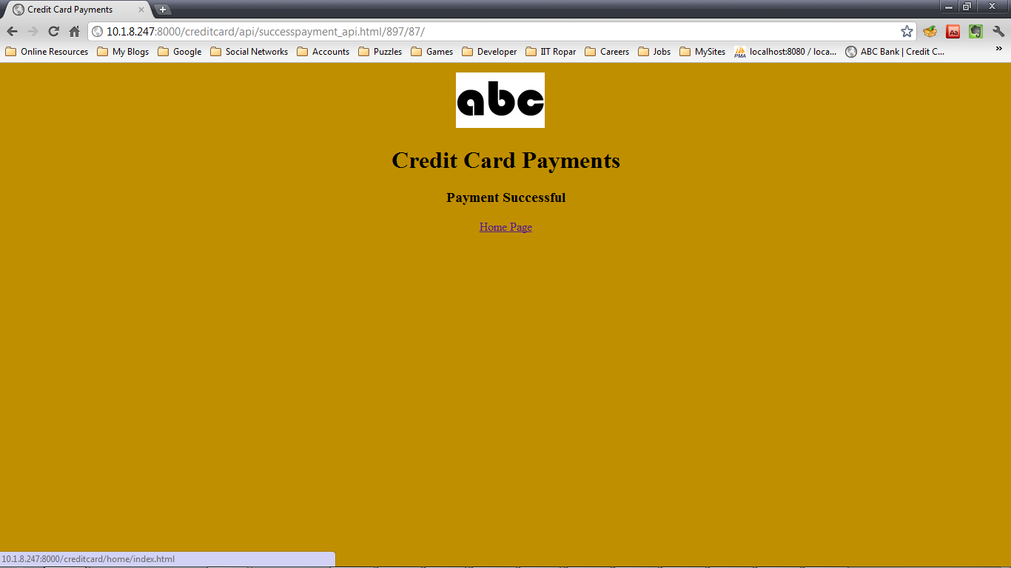

The amount mentioned is credited in the customer’s account and the third party is debited with the same amount in the mentioned account number.

**Input needed:**

Account number, Amount

**Result:**

Transfer via credit card completed.